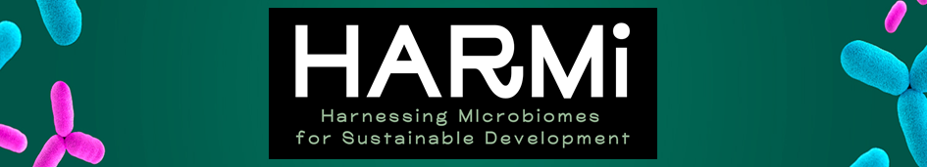

**Young talents program**

**(Tenure-Eligible Junior Professor Chair Position)**

**Understanding and steering microbial communities in agroecosystems to enhance the delivery of ecosystem services**

Complete the requested information and send the items in ONE file (pdf format; file name : CPJ-HARMI2025-[Your_Name].pdf) directly to [harmi@ubfc.fr](mailto:harmi@ubfc.fr)

**Application for a Junior Professor chair**

1. A curriculum vitae (maximum 2 pages)
   1. Personal information

|  |  |
| --- | --- |
| **Surname** |  |
| **Given name** |  |
| **Title (Mr / Mrs)** |  |
| **Nationality** |  |
| **Date of birth** |  |
| **Title, place and date of PhD** |  |
| **Email** |  |
| **Mobile phone** |  |
| **Postal address** |  |
| **Professional address** |  |
| **ORCID/researcher ID/google scholar** |  |

* 1. Professional experience

|  |  |  |
| --- | --- | --- |
| **Year** | **Position** | **Organisation or institution** |
| Most recent |  |  |
| … |  |  |
| Oldest |  |  |

* 1. Scientific expertise (maximum 10 lines)
  2. Keywords (maximum 5)
  3. Major events in scientific career

List up to 5 highlights in your scientific career.

* 1. Professional service activities and responsibilities
  2. Relations with the socioeconomic world

Contracts, board member, consulting, role as expert, etc.

* 1. Outreach

List the opportunities/events that enabled you to share your work with the general public.

* 1. PhD supervision

Number of PhD students supervised :

Number of co-supervised PhD students :

Publications co-signed with those doctoral students :

*Attach your CV in free format to your application.*

2. Motivations of the candidate (2 pages maximum)

Specify what you can bring to the Agroecology Department ​​and what the Agroecology Department ​​can bring to you.

Specify your suitability for the profile of the chair.

3. Research activities

* 1. Description of your scientific background (maximum 1 page)
  2. Scientific project relating to the Junior Professor position (maximum 5 pages)

3.2.1 Scientific context of the work envisaged

* + 1. Description of the scientific project
    2. Scientific hurdles linked to the project
    3. Indicators to monitor the progress of the project
    4. Dissemination of the research among the general public
    5. Short and medium term perspectives

4. Teaching activities (if any, maximum 2 pages)

5. List of projects and funding obtained for the research activities

|  |  |  |  |  |  |
| --- | --- | --- | --- | --- | --- |
| **Year** | **Source (agency, public authority, company...)** | **Project title** | **Name of coordinator** | **Budget (€)** | **Your role in the project** |
|  |  |  |  |  |  |
|  |  |  |  |  |  |
|  |  |  |  |  |  |

6. List of publications, books, patents, oral presentations, posters

* 1. Summary

|  |  |
| --- | --- |
| Number of peer-reviewed publications |  |
| Number of other publications (proceedings, book chapters...) |  |
| Number of patents |  |
| Number of oral presentations |  |
| Number of posters |  |
| Number of guest speaker invitations |  |

* 1. Peer-reviewed articles

1. Title, authors, Journal, Volume, pages (year) Number of citations
2. …….
   1. Other publications (proceedings, book chapters...)
3. Title of proceedings, authors, journal, volume, pages, (year) Number of citations
4. …….
   1. Patents

Fill in a table for each patent

|  |  |
| --- | --- |
| **Name** |  |
| **Inventor(s)** |  |
| **Patent number** |  |

* 1. Oral presentations

1. Presentation title, conference title, conference acronym, date, town, country
2. …..
   1. Posters
3. Poster title, conference title, conference acronym, date, town, country
   1. Guest speaker/keynote invitations
4. Title of seminar, Meeting/congress, date, town, country
5. …..